Website template example.

<https://startbootstrap.com/previews/agency/>

Color Palette

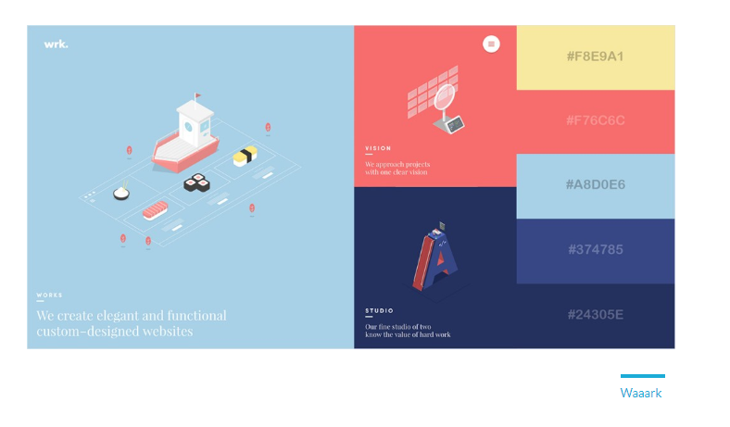

#F8E9A1

#F76C6C

#A8D0E6

#374785

#24305E